1. Write a program that takes two strings from the user: first name last name. Pass these variables to full name function that should return the (full name).

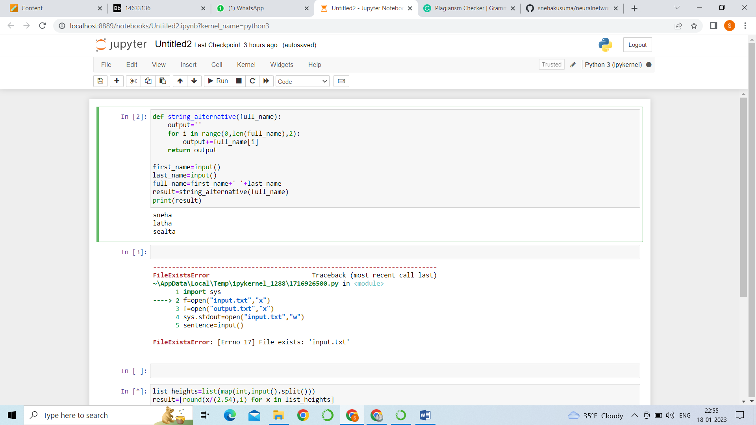

A brief description about 1st question:

Here, am attaching a code with output for our reference sir. So, I am using string alternative to get alternatives letters of the given word.

2.Write a python program to find the word count in a file (input.txt) for each line and then print the output

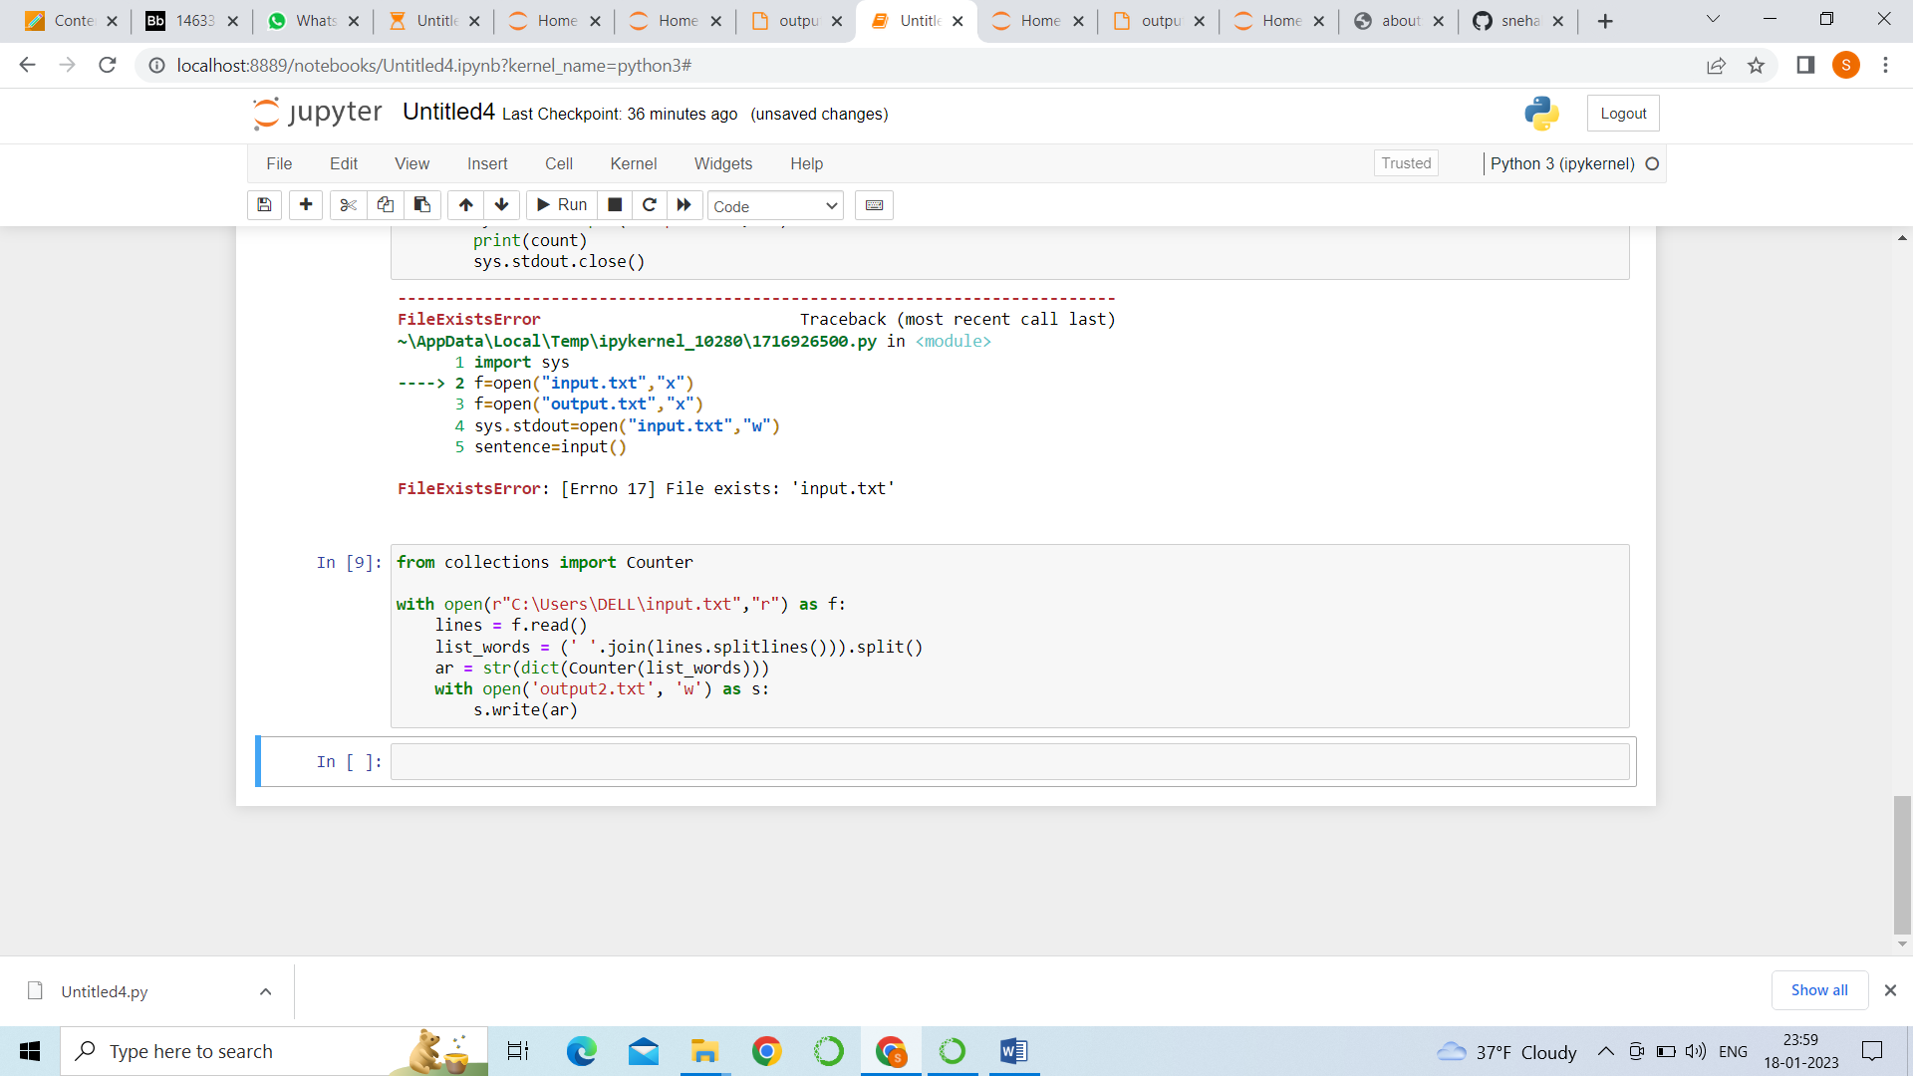

Output:

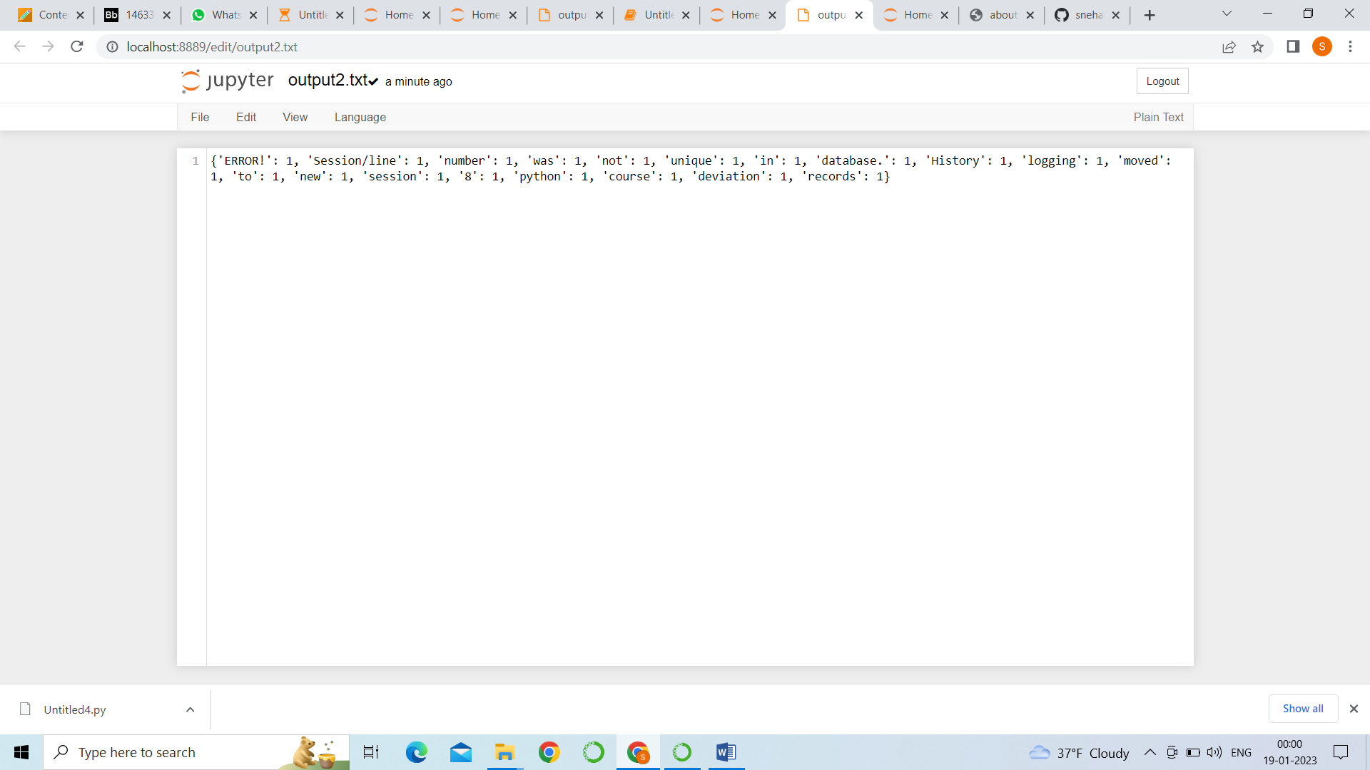

1. Write a program, which reads heights (inches.) customers into a list and convert these heights to centimeters in a separate list using: 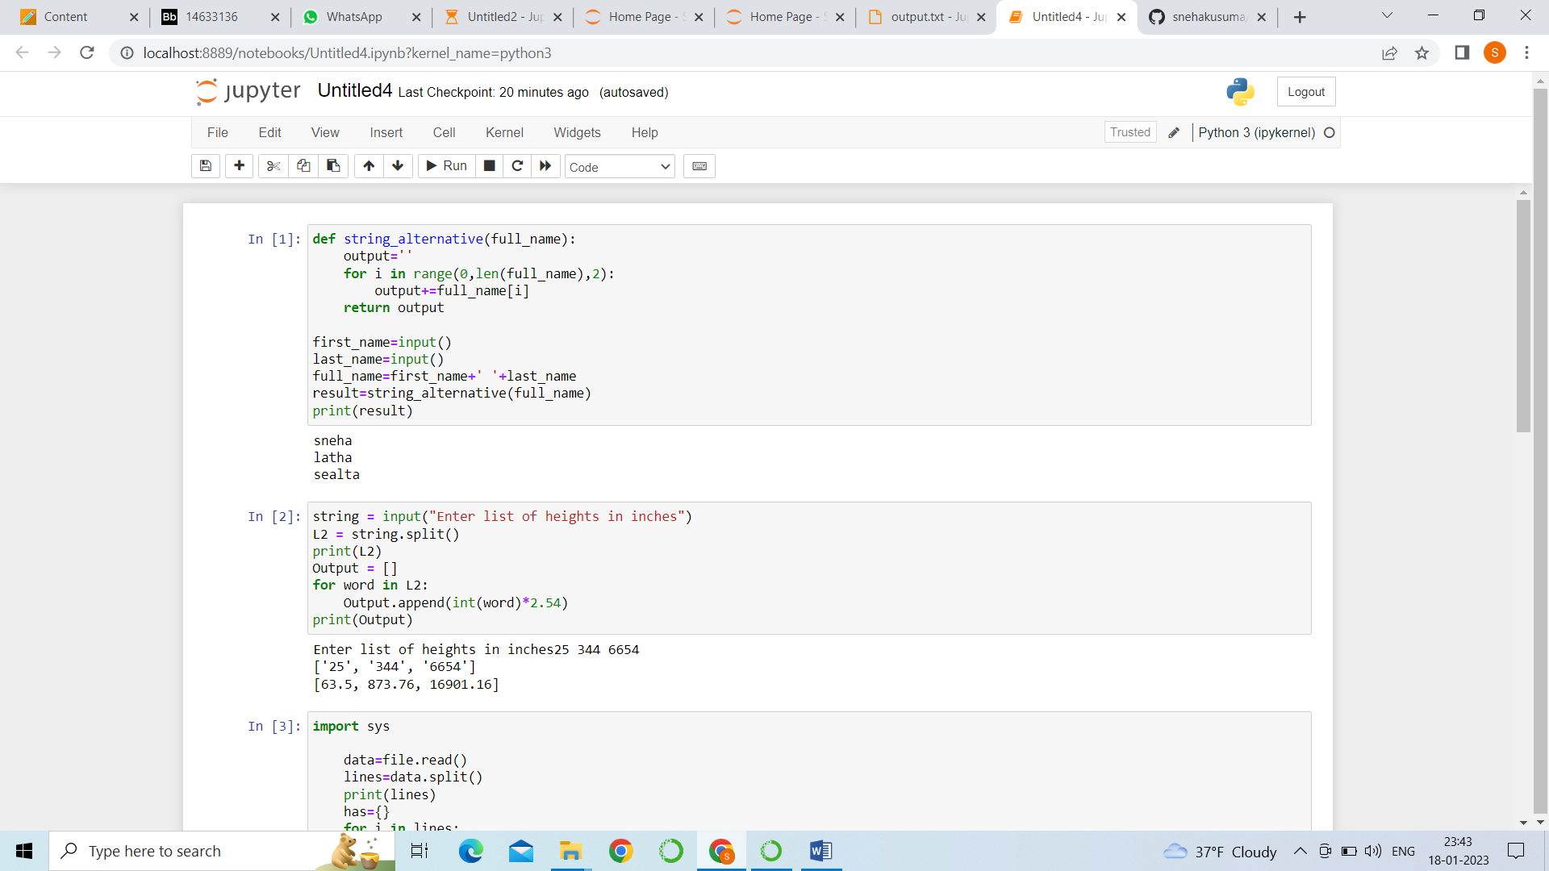

GITHUB LINK:

<https://github.com/snehakusuma/neuralnetworkassignment2>